Table 1. Four EEG parameters considered to establish the EBRI models.
EEG parameters | Definition
BSR (unit: %) | Burst suppression ratio; percentage of continuous periods longer than 0.5 second during which EEG is suppressed under ±5 μV
SynchFastSlow | Relative synchrony of fast and slow wave; log(B_{0.5-47 Hz} / B_{40-47 Hz})
BetaR | Relative beta ratio; log(P_{30-47 Hz} / P_{11-20 Hz})
DeltaR | Relative delta ratio; log(P_{8-20 Hz} / P_{1-4 Hz})
Abbreviation: P_{a-b Hz}, the sum of spectral power from a-b Hz; B_{a-b Hz}, the sum of bispectral activity from a-b Hz

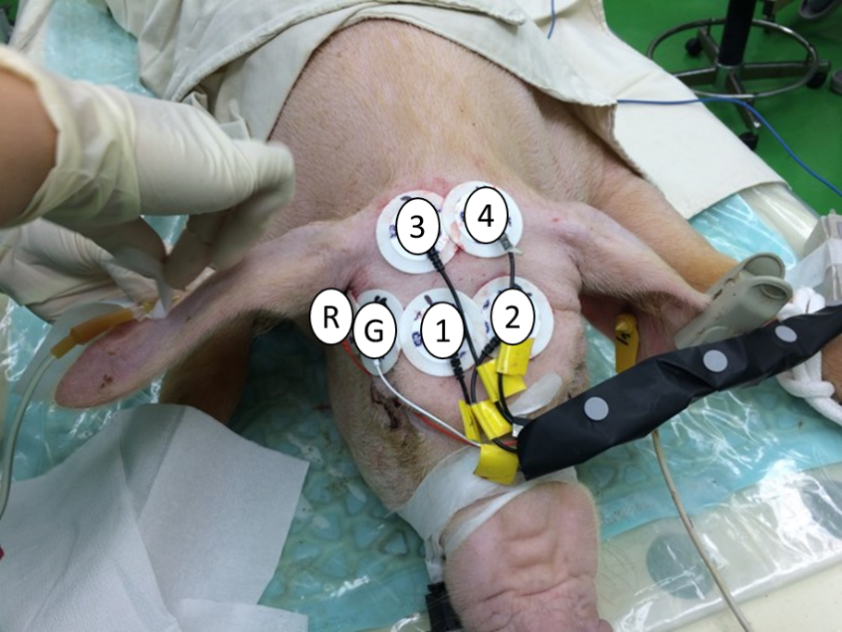
Fig. 1. Electrodes placement for EBRI measurement. R, reference electrode; G, ground electrode; 1~4, active electrode on the frontal area of scalp

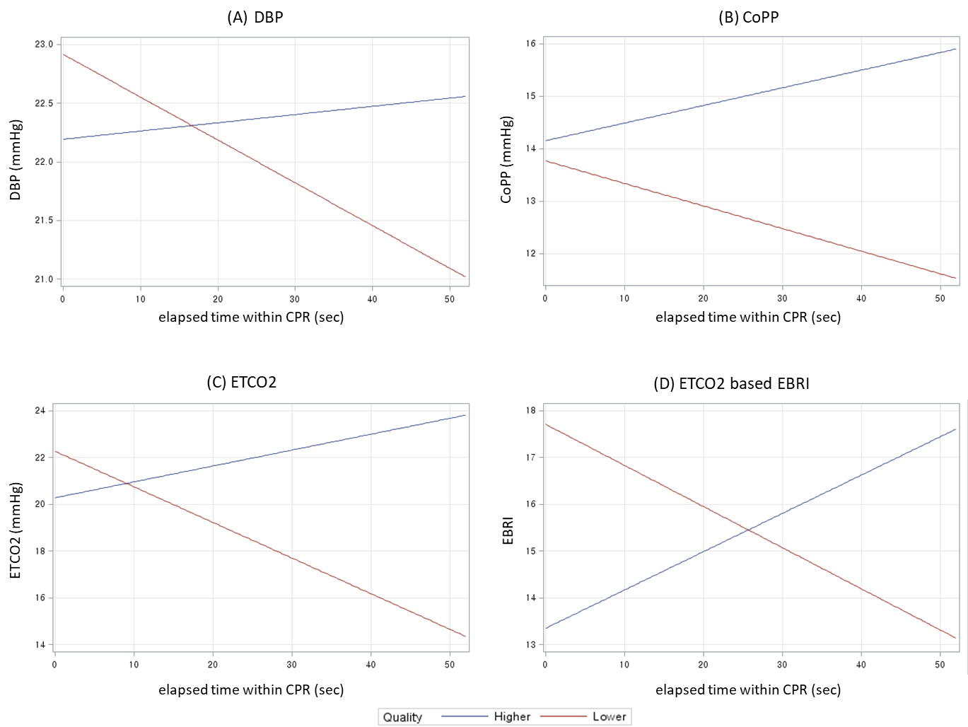
Fig. 2. Interaction plot for CPR parameters and elapsed time between higher CPR quality and lower CPR quality (A) DBP, (B) CoPP, (C) ETCO2, (D) EBRI. Abbreviations: DBP, Diastolic blood pressure, CoPP; Coronary perfusion pressure; ETCO2, end-tidal CO2; EBRI, EEG-based brain resuscitation index.

(A)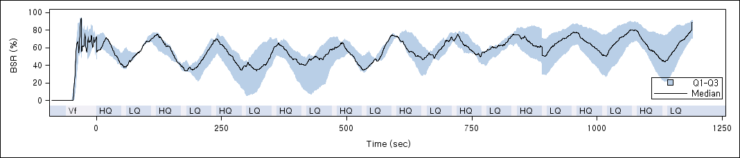
(B) 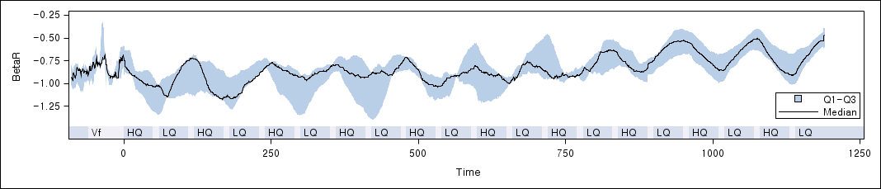
(C)
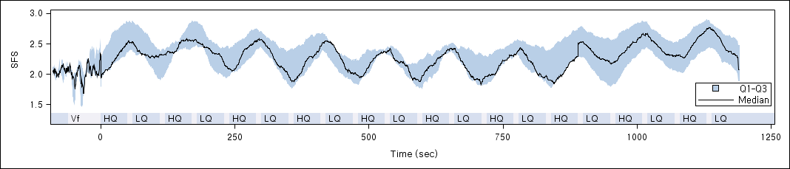
(D)
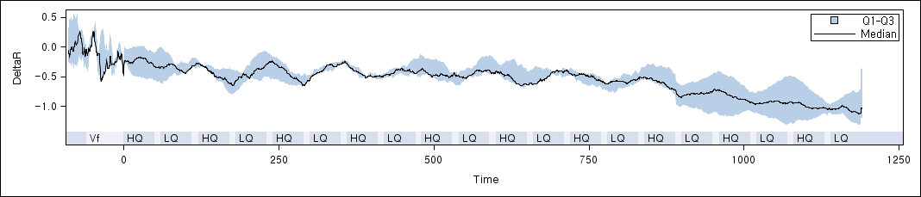
Fig. 3. Trend of EEG components over time (A) Burst suppression ratio(BSR), (B) Relative beta ratio, (C) Relative synchrony of fast and slow wave(SFS), (D) Relative delta ratio.

